

Capel 5 and Fun Run – 12 October 2025

**General information:**

Race HQ is located at the pavilion, Friars, Capel St Mary, IP9 2XS.

Toilet facilities will be available within the pavilion as well as additional portaloos on the playing field.

There will be a bag drop area. **If using the bag drop please ensure that you do not recycle your race number until after you have collected your bag as this will be required for collection.** Whilst every effort will be made to ensure the bag drop area is secure, all bags are left at your own risk. We do not recommend leaving mobile phones and other valuables.

There will be a selection of cakes and savouries plus hot and cold drinks available both before and after the race.

**Parking**

Parking is located in the overflow car park next to Bypass Nurseries Garden Centre on London Road, Capel St Mary, **IP9 2JR (**2-minute walk to the pavilion). There is also a small car park on the playing fields, entrance is on London Road opposite Bypass nurseries. Car Park marshals will be there to direct you on the day and please follow their instructions. Please car share where possible. **Do not park in the main Garden Centre car park which is exclusively for garden centre customers**.

**First Aid**

St Johns Ambulance will be based at the pavilion in case of any medical problems. Please complete medical and contact information on the back of your race number before running.

**5 mile race**

Race numbers are to be collected on the day from Race HQ between 8.30am and 10.00am.

The start line is on Rembrow Road, a few minutes’ walk from Race HQ so please listen out for the call to proceed to the start line approximately 15 minutes before the **start of the race which will be at 10.30am.** Please be aware that the road is open to traffic and therefore keep to the side of the road when walking to the start area.

Water will be available at the end of the race, there is no drink station on the route. If, due to weather conditions or your personal circumstances, you feel you may need extra water, we would encourage you to bring some along and carry it with you during the race if necessary.

A photographer will be taking pictures along the route so don’t forget to smile if you can! Photographs will be uploaded to the Capel Cheetahs Facebook page as soon as possible after the race.

The finish is on Playfield Road, close to the pavilion. All runners will receive a medal at the finish. Results will be sent out by SMS and email shortly after you cross the finish line. Full results will also be available through Racesonline

Trophies and prizes will be awarded at about 11:45 at the pavilion.

Transfers are available if you have entered but are unable to run, via the Capel Cheetahs facebook page [(1) Capel Cheetahs Running Club | Facebook](https://www.facebook.com/groups/313842825375624) , once you have found someone to transfer to you can follow the link on the email you received from your original entry to update us with the new runners details. Transfers can be made up until midnight the day before the race.

The race is run under UKA regulations so for safety reasons no in ear headphones are permitted, **anyone wearing in ear headphones will be disqualified.** Bone conducting headphones are allowed but please ensure that volume is kept at a level where you can clearly hear marshal’s instructions.

**Safety**

The Capel 5 course is on open roads (see route map below) and therefore runners should adhere to the Highway Code at all times and run on the left hand side of the road unless instructed otherwise. Please be aware of your surroundings and follow the instructions of marshals.

There is a road crossing in the village shortly after the start (and again on return). Whilst marshals will do their best to stop traffic at this location, please be aware that drivers may ignore their reasonable requests. Be vigilant and give way to vehicles if necessary.

**Important note:**

Taking part in the race means you agree that we may publish your Personal Information as part of the results of the event and may pass such information to the governing body or any affiliated organisation for the purpose of insurance, licences or for publishing results either for the event alone or combined with or compared to other events. Results may include (but not be limited to) name, any club affiliation, race times, gender and age category.

**Children’s Fun Run:**

The children’s Fun Run of approximately 1 mile **will start at 9.45 am**. Race number and timing chip can be collected from 8:30am at the pavilion.

The Fun Run takes place entirely on the playing field around a marked route. Children can run on their own but may be accompanied by a responsible adult if they so wish.

All runners will receive a medal and treat at the end of the race.

Prizes will be awarded for category winners at about 10:15 for 1st boy under 8, 1st girl under 8, 1st boy under 11, 1st girl under 11, 1st boy under 15 and 1st girl under 15.

A photographer will be taking pictures which you can download after the race. **Please let photographer know if you do not want your child photographed.**

I look forward to seeing you on the day. Have a fun and safe run.

John Dunnett,

Race Director

**Capel 5 Course Map**

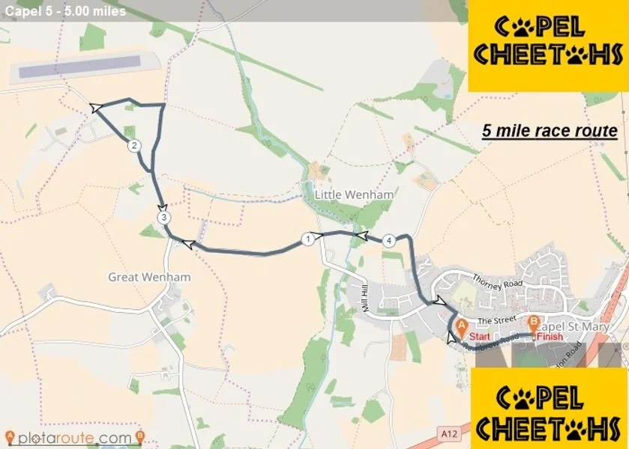

**Sponsors**







